Pre-Reading

Unfortunate Weather
The first character 去 (qu4) might be review, but let’s look at it again. The top part is a 土 which means dirt or ground, but the top part of 去 used to be a person, the bottom part means private or secret, so this character represented someone leaving their home. Today 去 just means “to go.” The next character is 找 this character is made of a hand radical on the left (same as in: 打，擦，扫), the right side is 戈 (ge1) which means spear or halberd, so you can imagine a hand looking for a spear and then you get that 找 means “to search for or to look for.” The next word to note is 但是 (dan4shi4), which simply means “but.” Following this we see the word 离开 (li2kai1) literally means separate and start. Together they mean to depart, or starting to depart. The next phrase is a bit difficult to comprehend的时候 (deshi2hou4), means when, but it usually comes after the verb. So 我打篮球的时候, means “When I play basketball,” this can be confusing for some people so pay attention to the word order. The next word 突然 (tu1ran2) ，means “suddenly.” To make sense of this let’s first look at the 突 which is comprised of a 犬 which is the dog radical and the top radical 穴，which means cave, so suddenly refers to a dog suddenly coming out of a cave. Following this the author and his sister talk about the weather they mention 下雨 (xia4yu3), 多云 (duo1yun2), and 晴天 (qing2tian1). The first one 雨 is pretty self-explanatory it means “rain” when 下is added it means rain is falling as the character suggests. When the rains stops we say 雨停了 (yu3ting2le), where 停 literally means “stop.” Often times you will hear the teacher say 停！which means “stop what you are doing.” The next word 多云 has two parts the first 多means “many” as you can see there are two parts and two is too many in this case. The second word 云 means clouds, so you can guess that 多云means cloudy. Finally, 晴天, the second character 天simply means “day” or sometimes “sky/heaven” so here we can assume that 晴 is going to describe the day. If we look closely at the left side you’ll see 日which is the character for sun. So you should be able to guess that 晴天means sunny day. The next word that you have not seen is 现在 (xian4zai4) which means “at present” or “now” so could say 我现在不去, which would means “Now, I am not going.” The next phrase can also be difficult so pay attention to its structure, 越来越 (yue4lai2yue2) which means “more and more.” But in the story it says “下得越来越大” the first 下refers to the rain coming down, the second character 得 allows the following phrase to describe the verb下 and the last character 大 means “big.” So we can translate this “it rained more and more big” or “it rained harder and harder.” The last two structures we have are 喜欢 (xi3huan1) and 同意 (tong2yi4). The first one 喜欢 “I like” the first character 喜 is composed of 壴 on top which means somebody hitting a drum and a 口on the bottom which implies someone laughing happily. Both of these characters 喜and欢 have happy in their meaning so when they come together it is to describe something that makes you happy, or something makes you not happy such as in 不喜欢. Finally, the last word 同意 is made of two characters the first 同 simply means “same” and the second character 意 simply means “meaning” so “same meaning” means “to agree.” 我不同意would then mean “I do not agree!”
Story Character Count = 75
Vocabulary/Writing

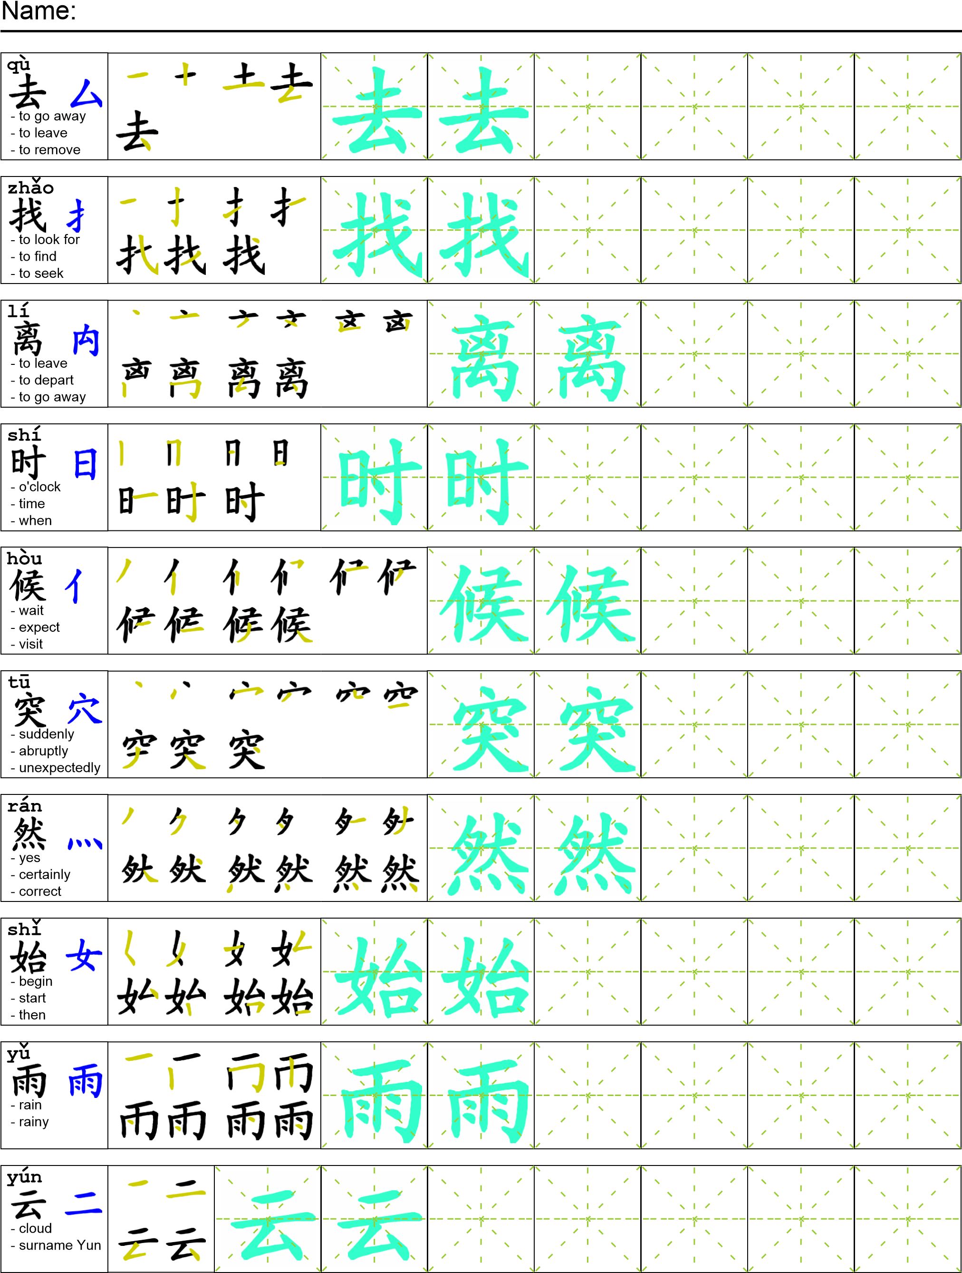
Reading

我和妹妹去找我爸爸。但是离开学校的时候突然开始下雨了。早上多云但是还没有下雨，现在下得越来越大。我说“我不喜欢下雨天我喜欢晴天。”我妹妹同意了。终于雨停了，我们去找爸爸。
Task Completion

Once all tasks are complete turn the assignment in to collect the points for the project.
Task 1: Trace the vocabulary and copy the text into your notebook.

Task 2: Answer Comprehension Questions.

Task 3: Write the Pinyin for the Reading.

Task 4: Translate the Reading into English.

Task 5: Record yourself reading the passage.

Comprehension Questions

